Valhalla’s Historical Artifact Inlays
“We are extremely proud of our inlays. I have been on a relentless search for historically significant materials and I am deeply thankful to all those people who have assisted me in the procurement and ultimately the sharing of these precious artifacts. They are NOT for sale. We use them when appropriate. Each artifact is proof of the honor, courage and commitment of those who served before us and are serving today.” Jimmy Hintzke, Retired United States Navy SEAL

This case includes the following artifacts:
- A piece of uniform patch worn by a worker on The Manhattan Project.
- Teak from the Surrender Deck of the USS Missouri.
- Ocean sand from USS Arizona Memorial Site at Pearl Harbor, Hawaii, recovered by military divers.
- Steel from Boeing B-17 Flying Fortress.
- Beach sand from a battle site at Iwo Jima, Island in Ogasawara, Tokyo, Japan.
- Aluminum from a Japanese Kamikaze Plane that attacked USS Haraden.

The TEAM Who Made Your Case
The TEAM is comprised of three Gold Star Sons; an Aerospace and Ocean Engineering student at Virginia Tech; an Electrical Engineering student at ODU; a Retired SEAL's son who is a leader in the robotics academy; an active duty SEAL's son who is studying industrial design at JMU; an up-and-coming power hitter who is the son of an active duty SEABEE; and (not in the photo) a Retired Air force 3d artist; and a Navy 3d artist.

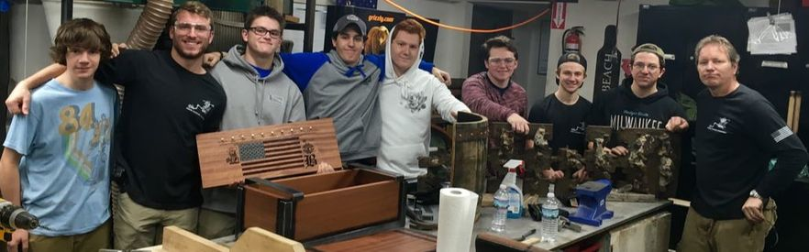

Valhalla's Forge LLC is a Veteran-Owned Family Business

The Manhattan Project, Production Team of the First Nuclear Weapon

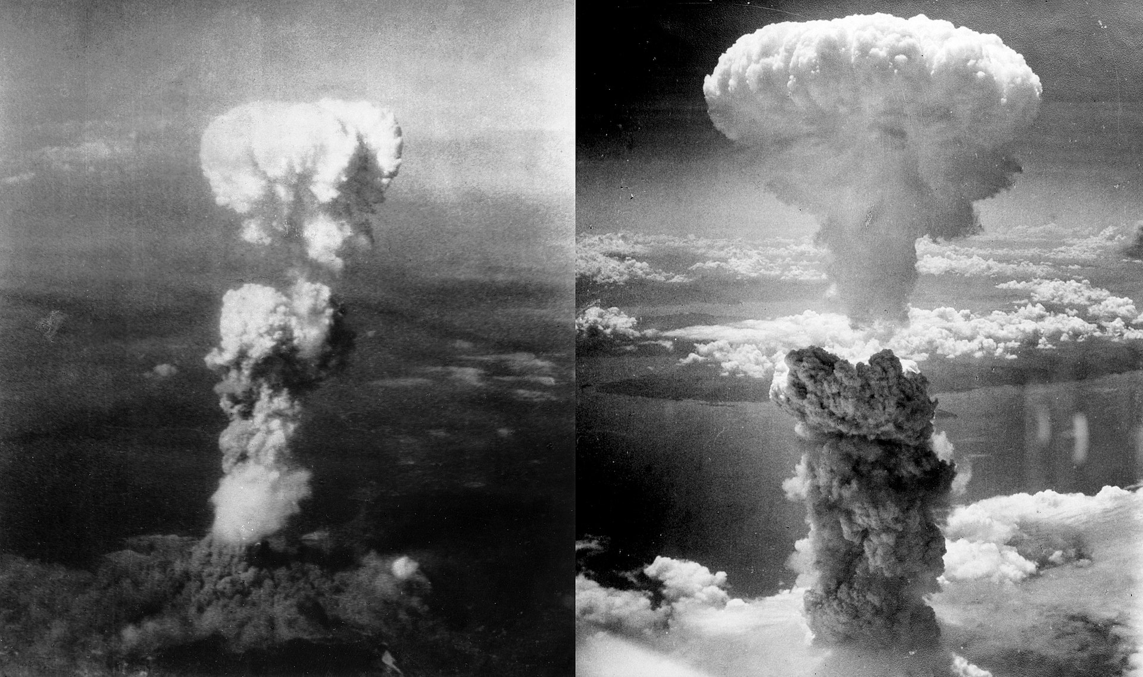

- Case includes a piece of a uniform patch worn by a worker on The Manhattan project.

The Manhattan Project was a research and development undertaking during World War II that produced the first nuclear weapons. It was led by the United States with the support of the United Kingdom and Canada. From 1942 to 1946, the project was under the direction of Major General Leslie Groves of the U.S. Army Corps of Engineers. Nuclear physicist Robert Oppenheimer was the director of the Los Alamos Laboratory that designed the actual bombs. The Army component of the project was designated the Manhattan District; Manhattan gradually superseded the official codename, Development of Substitute Materials, for the entire project. Along the way, the project absorbed its earlier British counterpart, Tube Alloys. The Manhattan Project began modestly in 1939, but grew to employ more than 130,000 people and cost nearly US$2 billion (about $23 billion in 2018 dollars). Over 90% of the cost was for building factories and to produce fissile material, with less than 10% for development and production of the weapons. Research and production took place at more than 30 sites across the United States, the United Kingdom, and Canada.

The first nuclear device ever detonated was an implosion-type bomb at the Trinity test, conducted at New Mexico's Alamogordo Bombing and Gunnery Range on 16 July 1945. Little Boy and Fat Man bombs were used a month later in the atomic bombings of Hiroshima and Nagasaki, respectively. In the immediate postwar years, the Manhattan Project conducted weapons testing at Bikini Atoll as part of Operation Crossroads, developed new weapons, promoted the development of the network of national laboratories, supported medical research into radiology and laid the foundations for the nuclear navy. It maintained control over American atomic weapons research and production until the formation of the United States Atomic Energy Commission in January 1947.

USS Missouri (BB-63), Surrender Site of the Empire of Japan that Ended WWII

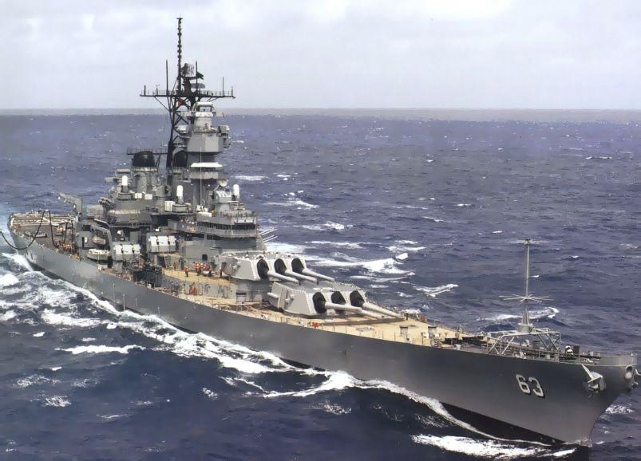
- Case includes teak from the Surrender Deck of the USS Missouri.

USS Missouri (BB-63) ("Mighty Mo" or "Big Mo") is best remembered as the site of the surrender of the Empire of Japan which ended World War II. It is an Iowa-class battleship and was the third ship of the United States Navy to be named after the U.S. state of Missouri. Missouri was the last battleship commissioned by the United States.

Missouri was ordered in 1940 and commissioned in June 1944. In the Pacific Theater of World War II she fought in the battles of Iwo Jima and Okinawa and shelled the Japanese home islands, and she fought in the Korean War from 1950 to 1953. She was decommissioned in 1955 into the United States Navy reserve fleets (the "Mothball Fleet"), but reactivated and modernized in 1984 as part of the 600-ship Navy plan, and provided fire support during Operation Desert Storm in January/February 1991.

Missouri received a total of 11 battle stars for service in World War II, Korea, and the Persian Gulf, and was finally decommissioned on 31 March 1992 after serving a total of 17 years of active service, but remained on the Naval Vessel Register until her name was struck in January 1995. In 1998, she was donated to the USS Missouri Memorial Association and became a museum ship at Pearl Harbor.

USS Arizona (BB-39), Pearl Harbor U.S. Naval Base near Honolulu, Hawaii

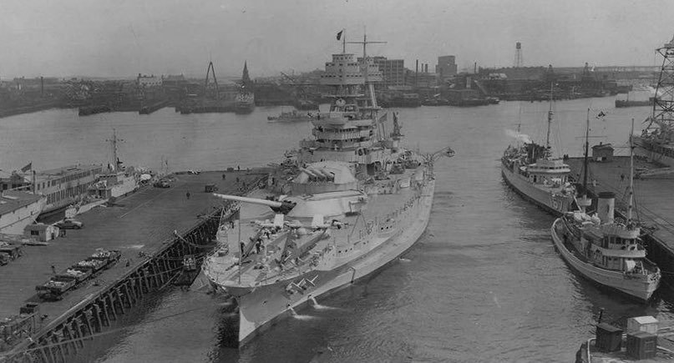

- Case includes ocean sand recovered beside the hull of the USS Arizona in 2019 by military divers.

USS Arizona was a Pennsylvania-class battleship built for and by the United States Navy in the mid-1910s. Named in honor of the 48th state's recent admission into the union, the ship was the second and last of the Pennsylvania class of "super-dreadnought" battleships. Although commissioned in 1916, the ship remained stateside during World War I. Shortly after the end of the war, Arizona was one of a number of American ships that briefly escorted President Woodrow Wilson to the Paris Peace Conference. The ship was sent to Turkey in 1919 at the beginning of the Greco-Turkish War to represent American interests for several months. Several years later, she was transferred to the Pacific Fleet and remained there for the rest of her career.

Aside from a comprehensive modernization in 1929–1931, Arizona was regularly used for training exercises between the wars, including the annual Fleet Problems (training exercises). When an earthquake struck Long Beach, California, on 10 March 1933, the Arizona's crew provided aid to the survivors. In July 1934, the ship was featured in a James Cagney film, Here Comes the Navy, about the romantic troubles of a sailor. In April 1940, she and the rest of the Pacific Fleet were transferred from California to Pearl Harbor, Hawaii, as a deterrent to Japanese imperialism.

Arizona was bombed during the Japanese attack on Pearl Harbor on 7 December 1941. After a bomb detonated in a powder magazine, the battleship exploded violently and sank, with the loss of 1,177 officers and crewmen. Unlike many of the other ships sunk or damaged that day, Arizona was irreparably damaged by the force of the magazine explosion, though the Navy removed parts of the ship for reuse. The wreck still lies at the bottom of Pearl Harbor and the USS Arizona Memorial. Dedicated on 30 May 1962 to all those who died during the attack, the memorial straddles but does not touch the ship's hull.

Boeing B-17 Bomber Flying Fortress
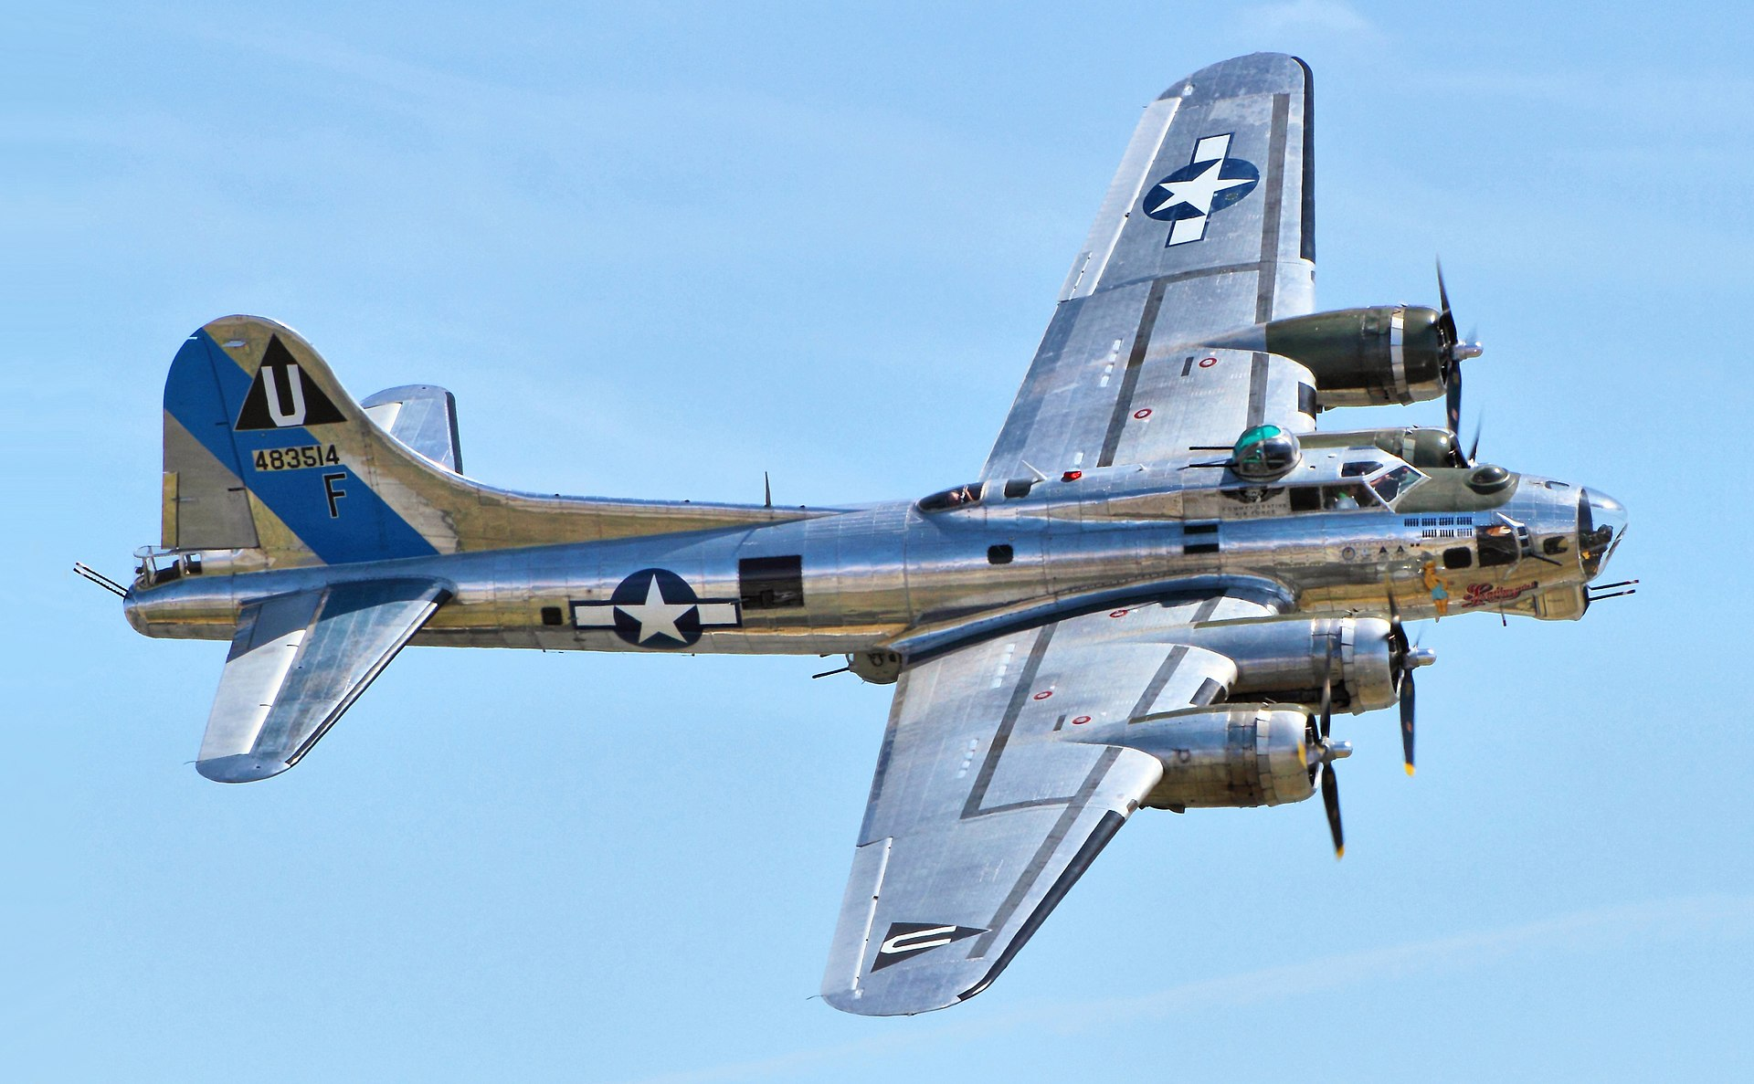

- Case includes steel from WWII B-17 Flying Fortress.

The Boeing B-17 Flying Fortress is a four-engine heavy bomber developed in the 1930s for the United States Army Air Corps (USAAC). Competing against Douglas and Martin for a contract to build 200 bombers, the Boeing entry (prototype Model 299/XB-17) outperformed both competitors and exceeded the air corps' performance specifications. Although Boeing lost the contract (to the Douglas B-18 Bolo) because the prototype crashed, the air corps ordered 13 more B-17s for further evaluation. From its introduction in 1938, the B-17 Flying Fortress evolved through numerous design advances, becoming the third-most produced bomber of all time, behind the four-engine B-24 and the multirole, twin-engine JU 88.

The B-17 was primarily employed by the USAAF in the daylight strategic bombing campaign of World War II against German industrial and military targets. The United States Eighth Air Force, based at many airfields in central and southern England, and the Fifteenth Air Force, based in Italy, complemented the RAF Bomber Command's nighttime area bombing in the Combined Bomber Offensive to help secure air superiority over the cities, factories and battlefields of Western Europe in preparation for the invasion of France in 1944. The B-17 also participated to a lesser extent in the War in the Pacific, early in World War II, where it conducted raids against Japanese shipping and airfields.

Iwo Jima Sand

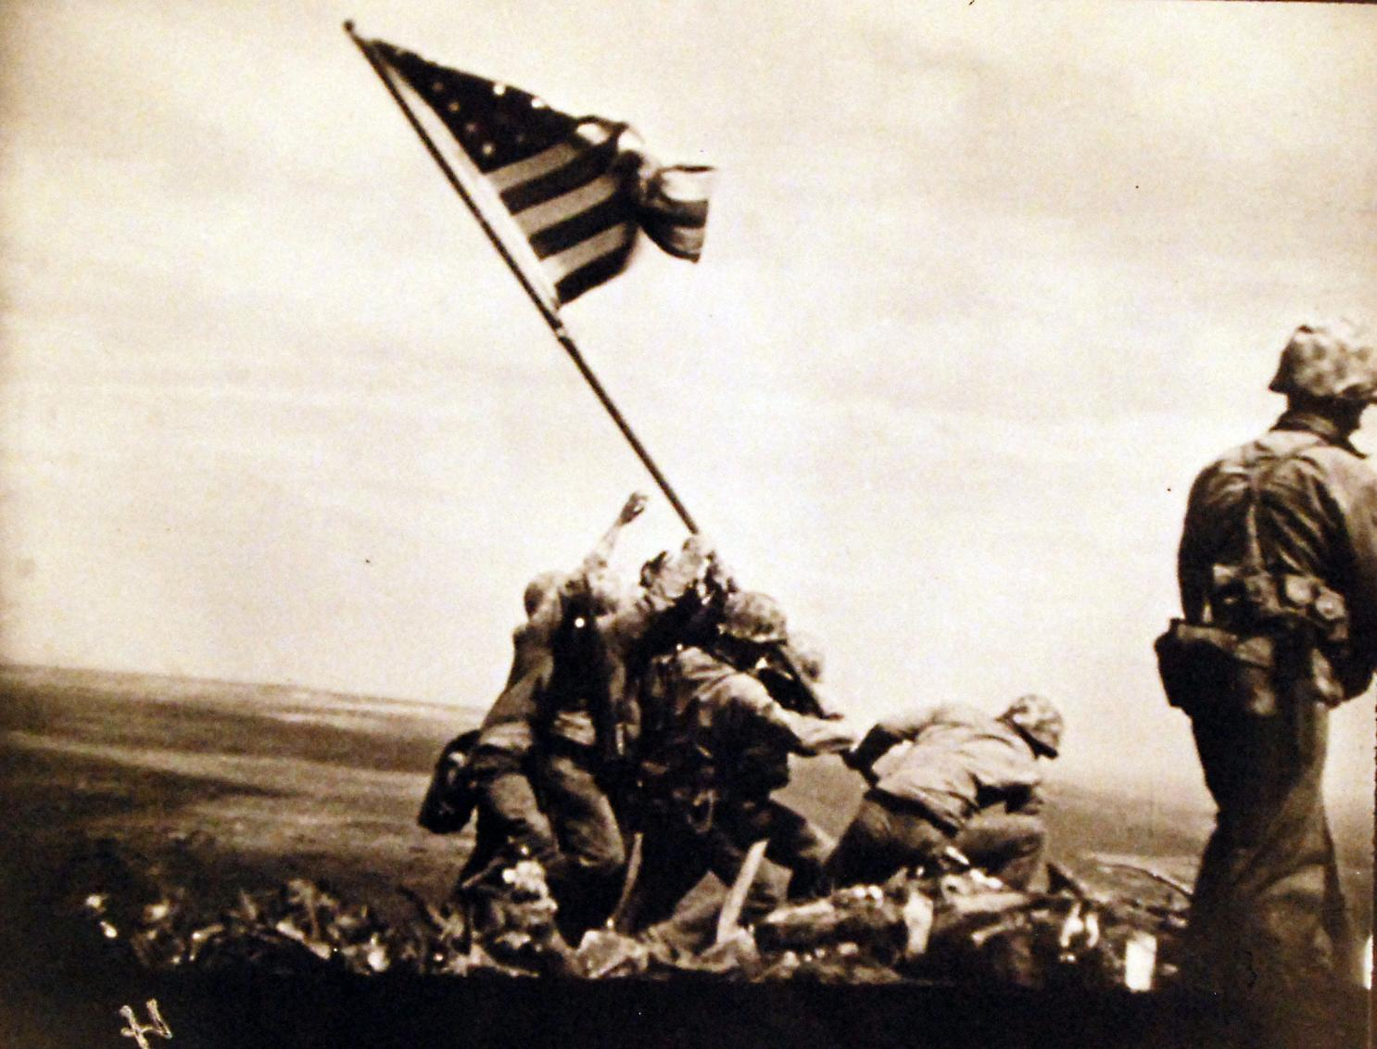

- Case includes beach sand from a battle site at Iwo Jima, Island in Ogasawara, Tokyo, Japan.

The Battle of Iwo Jima (19 February – 26 March 1945) was a major battle in which the United States Marine Corps landed on and eventually captured the island of Iwo Jima from the Imperial Japanese Army (IJA) during World War II. The American invasion, designated Operation Detachment, had the goal of capturing the entire island, including the three Japanese-controlled airfields (including the South Field and the Central Field), to provide a staging area for attacks on the Japanese main islands. This five-week battle comprised some of the fiercest and bloodiest fighting of the Pacific War of World War II.

USS Haraden (DD-585) attacked by Japanese Kamikaze 13 December 1944

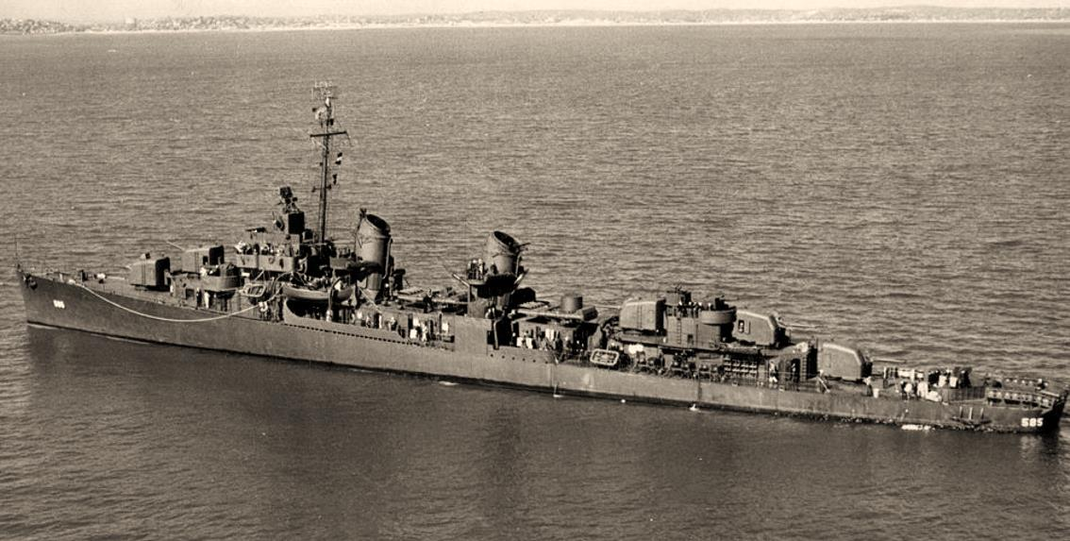

- Case includes aluminum from a Japanese Kamikaze plane that attacked USS Haraden.

On June 30, 1941, Daniel (Eugene) Kines of Lipscomb, Alabama turned seventeen years old and tried to join the U.S. Navy. His father and mother refused to sign the enlistment documents required for men under the age of eighteen; but Eugene continued to try to convince his parents to allow him to join over the next few months. It was not until the morning of December 8, 1941 that Eugene’s enlistment papers were signed and placed on the kitchen table. When he arrived at the recruiting station in Bessemer, Alabama only then did he learn why his parents had finally signed his papers.

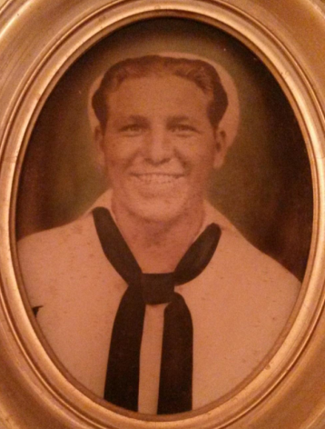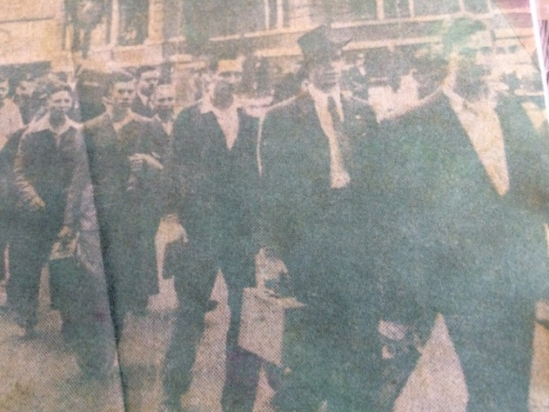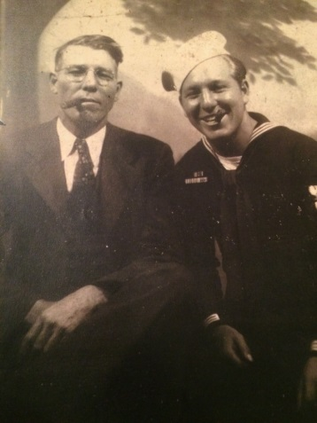
Photo 1: Daniel Eugene Kines
Photo 2: New recruits being marched to the bus station on December 11, 1941; “My father, Eugene Kines, is the first person on the left side of the photograph (captured in full). I believe the photo was published in The Birmingham News newspaper.” –Mike Kines
Photo 3: Reunion of Eugene Kines with his father after two years apart.

Immediately following basic training, SN Kines was assigned to the newly commissioned USS Hambleton (DD 455), a Gleaves-class destroyer out of Norfolk, Virginia. In October 1942, the USS Hambleton and crew joined the Western Naval Task Force off the coast of Africa and took part in Operation Torch D-Day on November 8. On November 11, while anchored off the coast of Morocco, USS Hambleton was struck amidships by a torpedo from the German submarine U-173. Nearly sunk, the USS Hambleton was towed into Casablanca where Seabees removed a 40-foot section of the damaged hull and rejoined the remaining two halves together. USS Hambleton slowly made her way to Boston, arriving on June 28, 1943 for permanent repairs. Most of her crew was reassigned to other ships in the U.S. Naval Fleet; and after returning home from a 7-day leave, BM3 Kines reported aboard the recently commissioned Fletcher-class destroyer USS Haraden (DD 585) in July 1943.

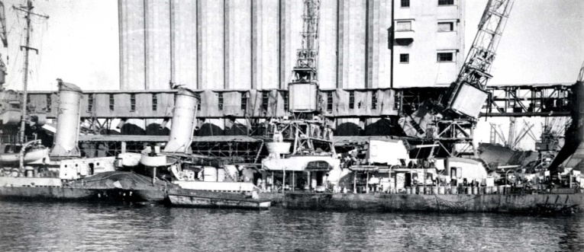

Destroyer USS Hambleton after being torpedoed on 11 November 1942.

On October 9, 1943, the USS Haraden left Boston and began the transit to the Pacific front. The Haraden took part in the invasion of the Marshall Islands (early 1944) and Marianna Islands campaign (summer 1944) performing naval shore fire support, antisubmarine patrols, and escort duties. In October 1944, the Haraden and her crew took part in the Battle of Leyte Gulf as part of the antiaircraft screen for the transports during the main assault. On December 13, 1944, while transiting the Sulu Sea in route to the invasion of Mindoro, the Haraden and her escort carrier group were attacked by 4 Japanese aircraft. The following is an excerpt from BM2 Kines’s journal describing the attack.

“Dec. 13, 1944. We have been in Sulu Sea for 3 hours. 1720 went to GQ. 1731 was hit by Jap plane. 4 planes came in at us we shot down 2… (Illegible) …ran the four, still came on we were hitting them with everything we had. He hit no. 1 stack. Good bit of damage. 15 dead or missing, 26 wounded badly. Been working hard the last 3 or 4 hours seems like 12. We are underway going to Leyte.”

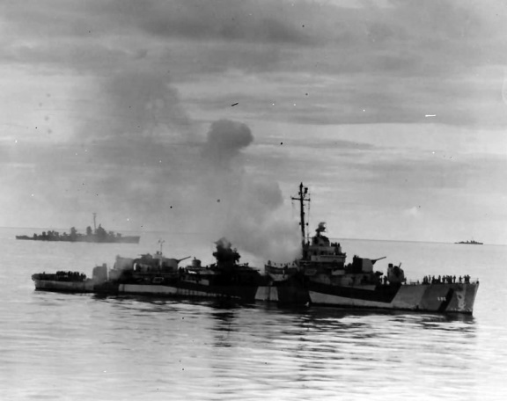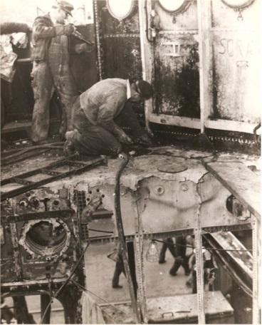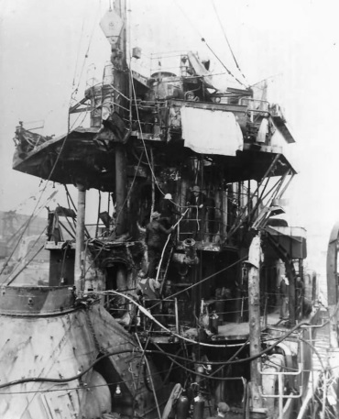

Destroyer USS Haraden DD-585 after Kamikaze attack in Sulu Sea, 13 December 1944.

Steel from the damaged Haraden and a small piece of aluminum from the Japanese Kamikaze plane were kept in Eugene’s possession along with a journal of his World War II experiences while onboard the Haraden. This rare artifact was gifted by Mike Kines, son of Eugene.

Shortly after the war ended, now BM1, Kines transitioned to the US Naval Reserves until he was recalled into active service in 1951 in response to the Korean Conflict. After the Korean Conflict, Eugene returned home to Alabama where he raised his family. His civilian career spanned over 50 years with the BellSouth Corporation and Communications Workers of America. Although he officially retired in 1986, he continued to work as a CWA union leader until a stroke forced him to end his life’s work in 2000. Eugene passed away with his family at his side on July 12, 2002.

Daniel Eugene Kines (30 June 1924 – 12 July 2002) is a forever a member of a time in U.S. history that we now refer to as the “Greatest Generation”. Kines’ desire to serve our Nation at time of war, selfless dedication and audacity in the face of opposing forces, and the legacy of a great family are the embodiment of this affectionate and deserved moniker.

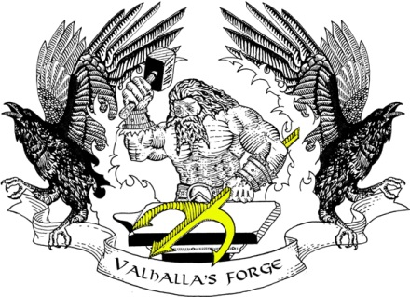
Valhalla’s Forge LLC
Made in the United States of America
We make great things for people who deserve it!

Valhalla's Forge LLC is a Veteran owned family business. For over 20 years, we have specialized in custom metal and wood work. We pride ourselves on our craftsmanship and customer service. Our intent is to craft the finest products anywhere! We separate ourselves from the competition with low overhead, diversity and capacity to utilize technology while paying respect to the artisans of old.

Our primary purpose is to assist our nation’s active duty military and their families. We are engaged with a number of different foundations, which include Task Force Dagger, The Navy SEAL Foundation, The Rosie Network, Semper Gratus Inc. and NSWKids. As a retired Navy SEAL, I know how important these groups are to those who go into harm’s way and especially for their families. The significant positive contribution they make cannot be overstated. Please join us in supporting them.

Jimmy Hintzke is a retired Navy SEAL who served over 30 years on active duty. Those years developed uncompromising standards and the ability to quickly identify and implement innovative solutions.

_________
www.ValhallasForge.com
2601 Production Rd., Suite 101, Virginia Beach VA 23454
www.etsy.com/shop/ArchRenTechniques
www.facebook.com/architecturalrenaissancetechniques
Instagram: @SEALARTISAN
757-374-4827
James@valhallasforge.com

